Author: Dr. Martin Freudenberger, Product Manager for pH and ORP

50 years of ISFET—The development of unbreakable pH sensors
The success story behind the development of ion-selective field-effect transistors as biochemical or biological sensors started 50 years ago. The first significant publication was written by P. Bergveld in 1970. It describes how ion activities in electrochemical or biological systems can be measured by combining the principles used in an MOS transistor and a glass electrode.
In the years that followed, developments took off in different directions, one of which was pH measurement. This development was driven by the prospect of being able to build an unbreakable, glass-free pH sensor of the type that had been needed for some time, particularly in applications in the food or life sciences sectors. After all, it was in the hygienic processes in these sectors that glass breakage in standard pH glass sensors often led to expensive production batches being discarded in their entirety.
The ISFETs are physically based on an MOS transistor arrangement in which the metallic gate, which functions as a control electrode, is replaced by an amphoteric metal oxide (e.g. Al₂O₃) or Si₃N₄. The medium comes into contact with this amphoteric layer. Hydronium or hydroxide ions from the medium accumulate or disperse at the surface in a ratio that corresponds to the pH value. There they give rise to a surface charge, which generates a Nernst voltage and is therefore an indicator of the pH value. This produces a mirror charge on the other side of the insulator, thus causing the area between the source and drain to become conductive (Fig. 1). This conductivity is proportional to the pH value of the medium and is analyzed by the transmitter electronics. The classic Ag / AgCl reference in 3 M KCl serves as the reference for the ISFET.
The original ISFET sensors were by no means appropriate to the task of controlling industrial processes, one of the problems being the encapsulation of the sensor chip to make it suitable for process conditions. However, the sensor's characteristics, such as its small dimensions, flat surface and scratch-resistant mechanical stability were promising enough to encourage further development of the product. It wasn't until the mid-1990s that the first commercially available ISFET suitable for process conditions was launched on the market by an American manufacturer.
While Endress+Hauser was already a major manufacturer of pH measuring technology at the time, they were not yet active in the field of ISFET. In 1996, a research project to develop an ISFET pH sensor was initiated in collaboration with the Fraunhofer IPMS Institute. Among other things, this required the development of a completely new transmitter. An important objective of this project was to meet the requirements of the food industry in particular. As part of the research work, a new gate material, Ta₂O₅, emerged as an improvement to the specification. This new gate material greatly improved long-term stability and operating life, and brought about a high level of stability in the case of steam sterilisation. The research also showed that, unlike glass electrodes, ISFETs have an extremely rapid response time even at low temperatures. This is because the measuring effect is not based on charge transfer, as is the case with glass electrodes, but on a potential-forming field effect that can only occur with very thin layers. In addition, ISFET pH sensors are highly suited to processes involving a high degree of organic chemistry. This is in contrast to classic pH sensors, which are of limited use in such cases due to the drying out of the pH-sensitive gel layer.
In 2002, the first pH ISFET sensors from Endress+Hauser were launched on the market, starting with a hygienic sensor, CPS471, with a gel-filled reference and ceramic diaphragm. High demand led to the development and market launch of ISFET sensors with a liquid KCl reference (CPS441) and a gel-filled reference with open aperture (CPS491). All of these sensors were still equipped with analog measuring technology, and so the next innovation involved the introduction of digital Memosens technology in 2004, initially for pH glass sensors. This was followed by the ORP parameter and in 2006, by the ISFET sensors CPS471D, 441D and 491D.
Thanks to the abovementioned characteristics, the pH ISFET sensors quickly established themselves in the key industrial sectors of food & beverages, life sciences and chemicals.
However, this first ISFET generation still had one weak spot, making them difficult to use, at least in the food & beverage sector. The usual cleaning process used here (cleaning in place) is performed with hot sodium hydroxide solution (2% NaOH) at a temperature of up to 85° C. None of the gate materials used up to that point were stable over the long term, with the result that ISFET sensors became unusable after a few alkaline cleaning cycles. The common solution to the problem was to use a retractable assembly, which removes the sensor from the process during alkaline cleaning, subjects it to an acidic cleaning process in the assembly and then inserts the sensor back into the process. The cumbersome nature of this procedure was outweighed by the benefit of break resistance. Nonetheless, this provided the incentive for the development of an improved, more alkali-stable gate material. This project was also carried out as a collaboration between Endress+Hauser and the Fraunhofer IPMS Institute. In the course of the project, it became clear that this latest development was mainly concerned with material science and had less to do with semi-conductor technology. Different oxides from transition metals, as well as multi-layer systems, were tested and ruled out as they did not have the required properties. At the end of the development process, a dual layer of Ta₂O₅ emerged as the most practical and optimum solution, with both layers being applied to the gate in different ways.
The outcome of this development is the new ISFET generation, which Endress+Hauser launched on the market in 2019 exclusively with Memosens technology. The new ISFET sensors, the CPS47D, 77D and 97D with the three tried and tested reference systems, completely replace the previous generation.
Thanks to the new gate material used, the CIP stability of these sensors has been improved by a factor of six. In addition, by increasing size of the chip surfaces and embedding the chip gate evenly in the PEEK surface, the risk of contamination of the sensors was reduced and cleanability greatly improved. The CPS77D and CPS47D, which are designed to comply with hygiene requirements, thus meet all of the essential regulations and requirements, such as USP 87, USP 88 class VI, USP 381, USP 661, 3-A, EHEDG, EU 1935/2004, FDA, TSE Compliance and RoHS.
During the developmental phase, there were also advances made in the production of ceramic diaphragms. Since then, Endress+Hauser has acquired the expertise to manufacture ceramic diaphragms of excellent, reproducible quality themselves. This is to the benefit of all pH sensors that use reference systems of this type.
Backward compatibility was a key feature during the market launch. Customers who are switching from the previous ISFET with Memosens technology to the new Memosens ISFETs do not need to make any adjustments to the transmitter. Both the hardware and software work straightaway with the new product.
The ISFET technology will continue to be developed; there is still the potential to improve the CIP resistance. Furthermore, a future alternative to the classic Ag/AgCl reference might also be based on FET, in the form of a reference field-effect transistor (REFET).

Picture material

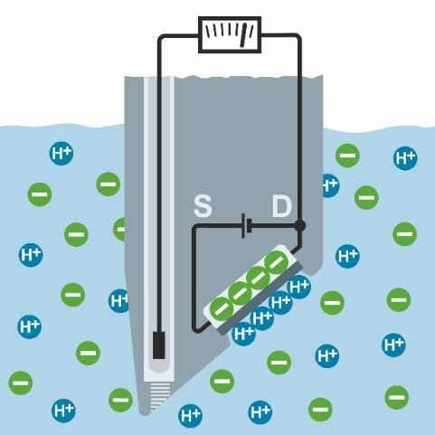
Fig. 1:
ISFET principle: The current between the source and drain of the semiconductor element depends on the charge at the source and therefore depends directly on the pH value.
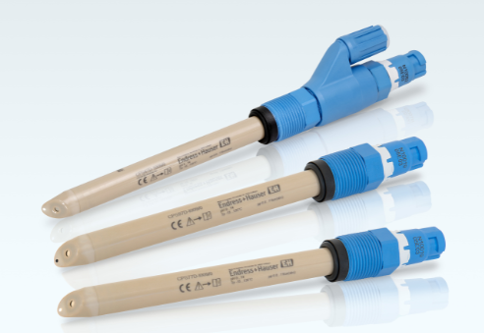
Fig. 2:
The new generation of ISFET sensors (from top to bottom)
Memosens CPS47D with ceramic diaphragm and liquid KCL reference
Memosens CPS97D with open aperture diaphragm and gel-filled reference
Memosens CPS77D with ceramic diaphragm and gel-filled reference

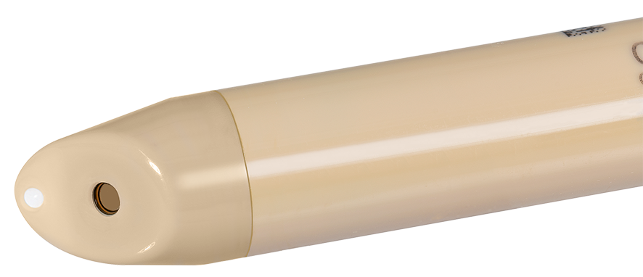
Fig. 3:
The new ISFET generation: increased chip surface and even embedding of the chip gate reduce the risk of contamination and improve cleanability
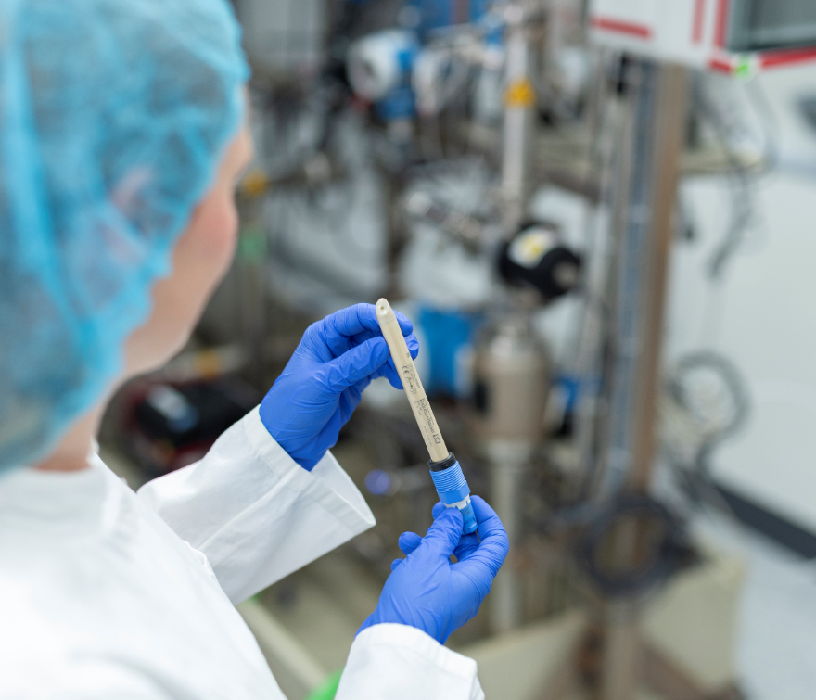
Fig. 4:
Glass-free ISFET pH sensors are excellently suited to the food industry

The Endress+Hauser Group
Endress+Hauser is a leading international supplier of measuring devices, services and solutions for industrial process engineering. The company group employs approx. 14,000 people worldwide. In 2018, it generated net sales of more than €2.4 billion.
Structure
Company-owned Sales Centers and a network of partners ensure expert support worldwide. With product centers in twelve countries, E+H is fast and flexible in meeting the needs of its customers. The company group is coordinated by a holding company based in Reinach/Switzerland. As a successful family-run business, Endress+Hauser wishes to remain an independent, unaffiliated company into the future.
Products
Endress+Hauser provides sensors, instruments, systems and services for level, flow, pressure and temperature measurement as well as analysis and data acquisition. The company supports its customers with services and solutions in the fields of automation engineering, logistics and IT. Its products are leading the way in terms of quality and technology.
Industries
Our customers are primarily from the chemical/petrochemical, food, oil and gas, water/wastewater, power and energy, life sciences, primaries and metal, renewable energies, pulp and paper and shipbuilding industries. With support from Endress+Hauser, they engineer their processes to be reliable, safe, cost-efficient and environmentally friendly.
History
Founded in 1953 by Georg H. Endress and Ludwig Hauser, the Endress+Hauser Group has been exclusively owned by the Endress family since 1975. The company has evolved consistently, from a level measurement specialist to a complete solutions provider for industrial measuring technology and automation. During this time, it has consistently developed new markets.
For further information, please go to www.endress.com/medienzentrum or www.endress.com

Contact
Martin Raab e-mail martin.raab@endress.com
Group Media Spokesperson Telephone +41 61 715 7722
Endress+Hauser AG Fax +41 61 715 2888
Kägenstrasse 2
4153 Reinach BL 1
Switzerland

(1) P. Bergveld, Development of an Ion-Sensitive Solid-State Device for Neurophysiological Measurements IEEE Transactions on Biomedical Engineering (Volume: BME-17, Issue 1, Jan. 1970)

